BrightLight Data Analytics Coding Practical
- Display all columns for all transactions.
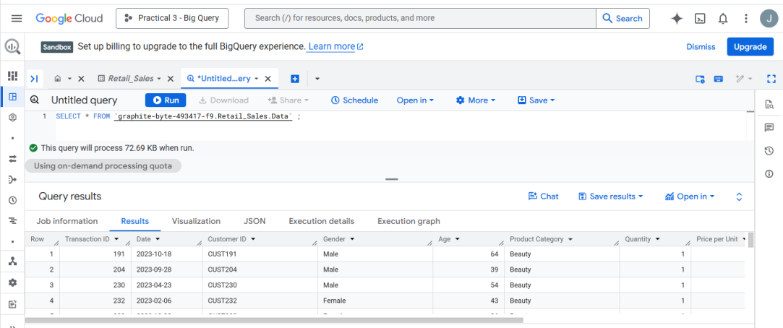

- Display only the Transaction ID, Date, and Customer ID for all records.
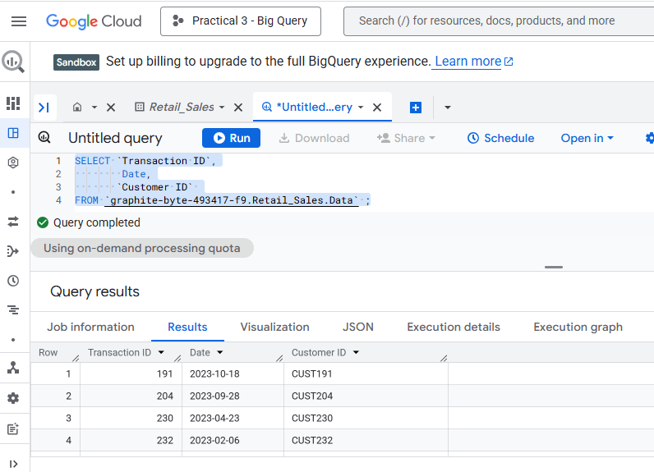

- Display all the distinct product categories in the dataset.
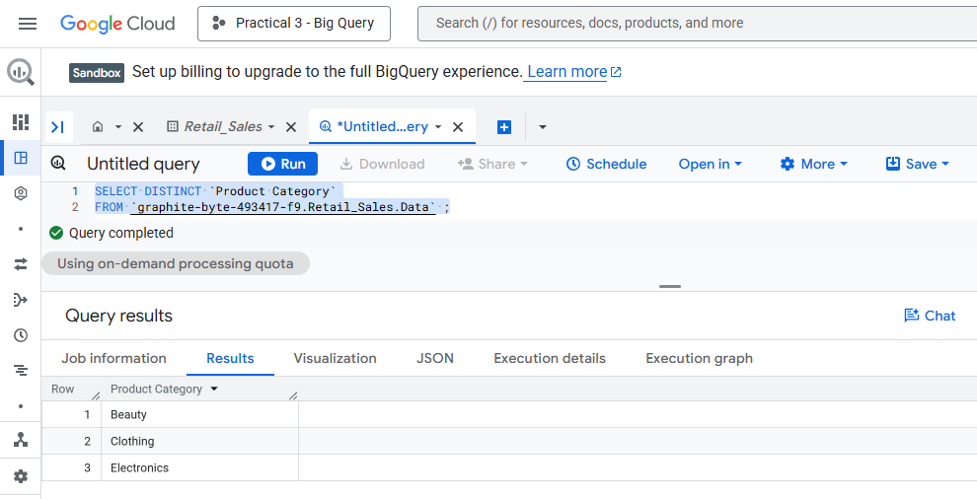
- Display all the distinct gender values in the dataset.
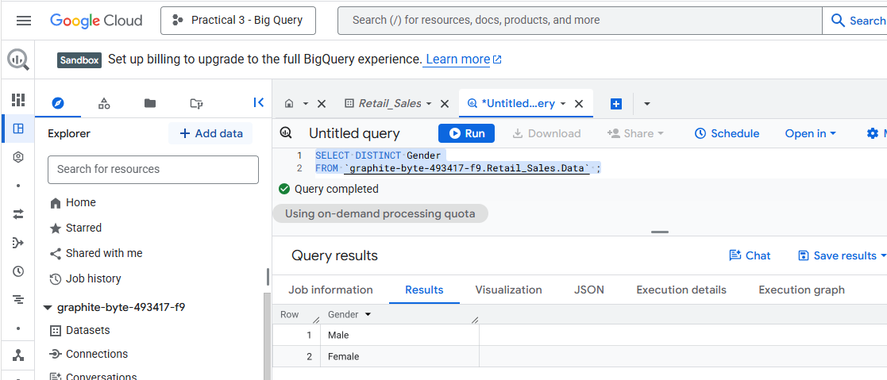

- Display all transactions where the Age is greater than 40.
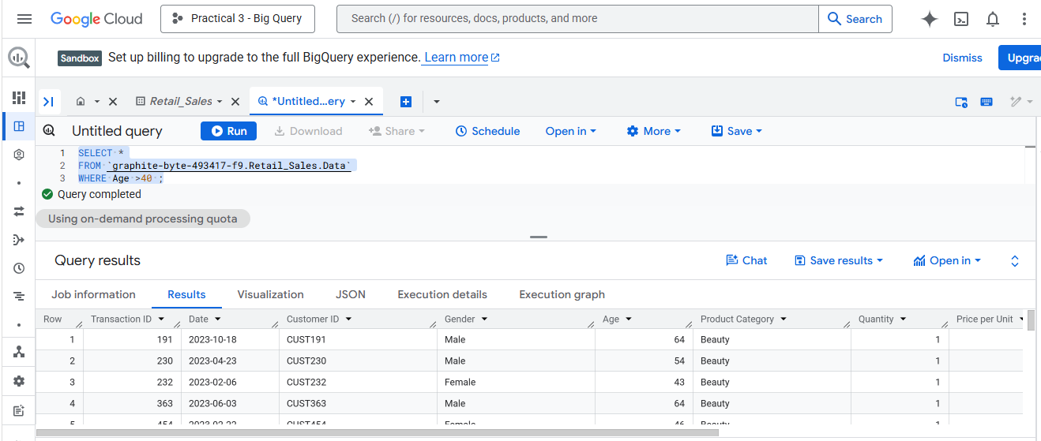

- Display all transactions where the Price per Unit is between 100 and 500.
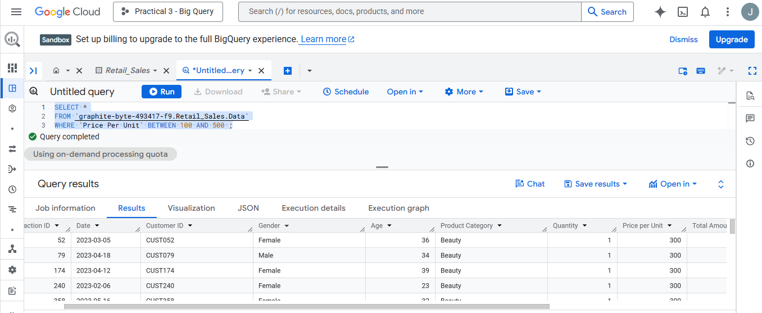
- Display all transactions where the Product Category is either 'Beauty' or 'Electronics'.
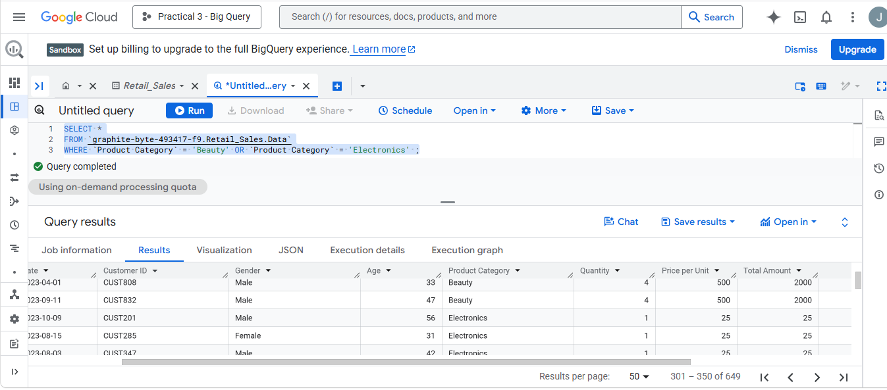
- Display all transactions where the Product Category is not 'Clothing'.
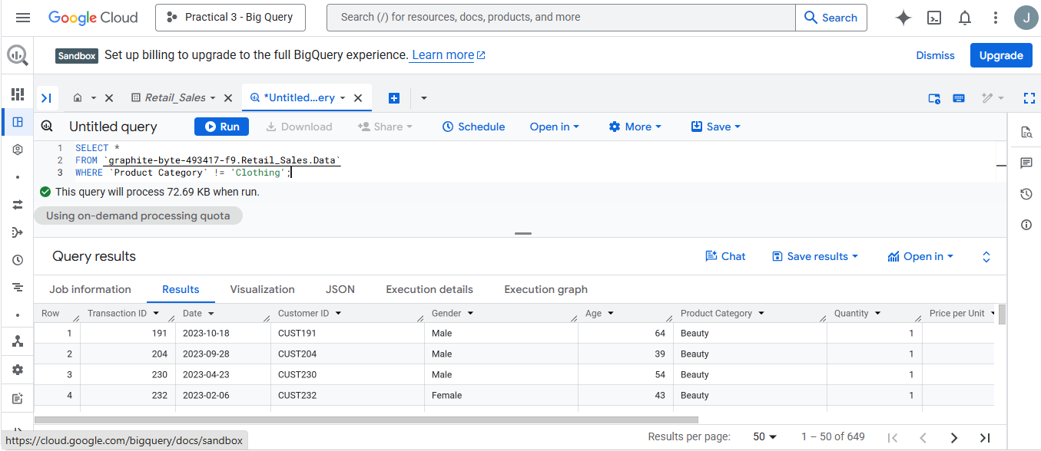

- Display all transactions where the Quantity is greater than or equal to 3.
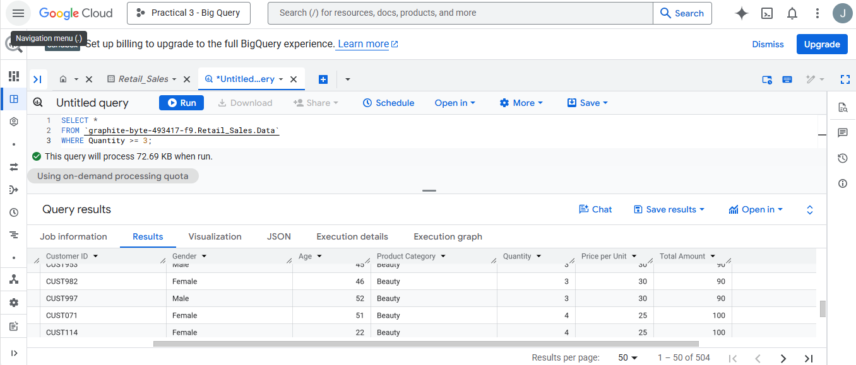
- Count the total number of transactions.
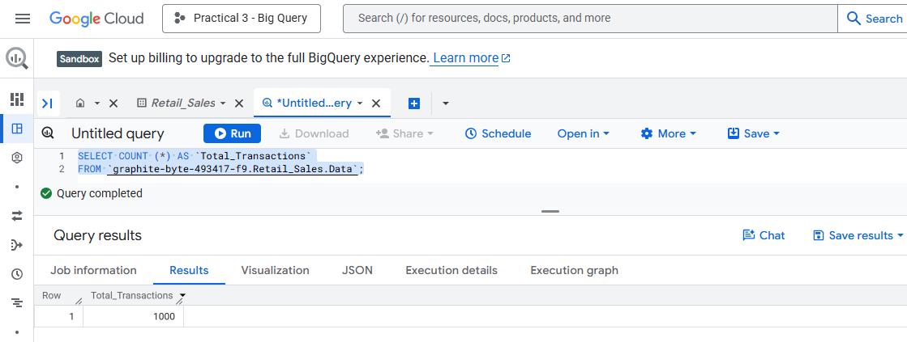
- Find the average Age of customers.
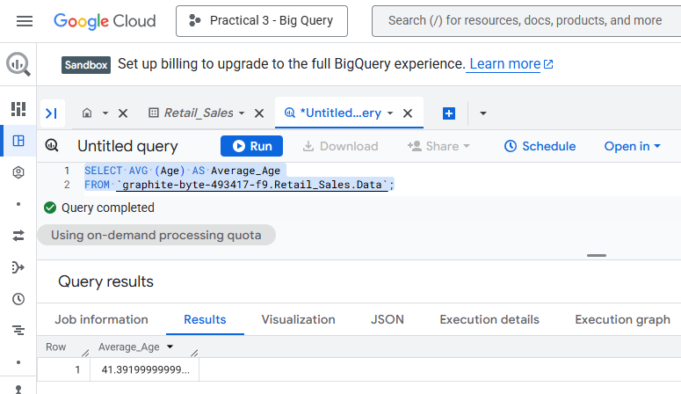
- Find the total quantity of products sold.
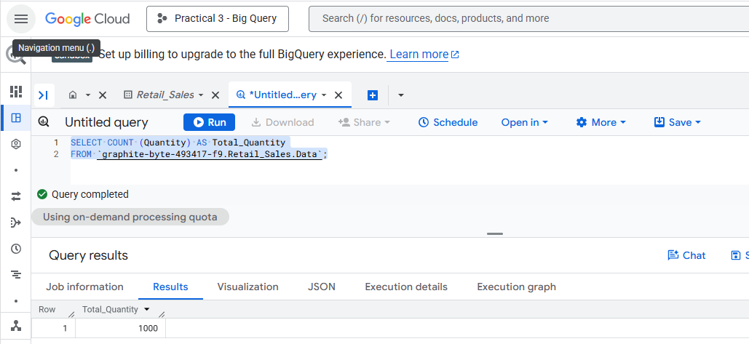
- Find the maximum Total Amount spent in a single transaction.
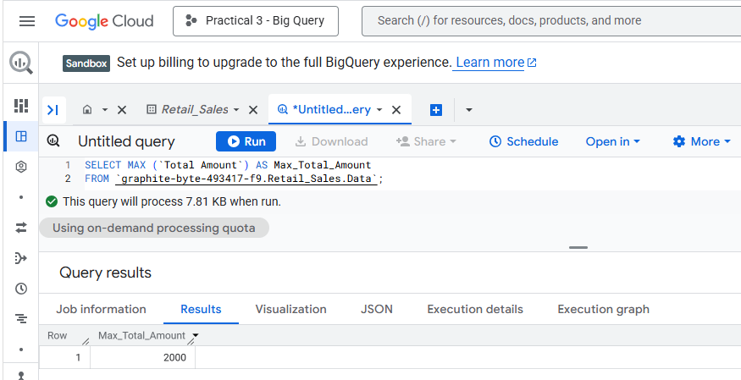
- Find the minimum Price per Unit in the dataset.
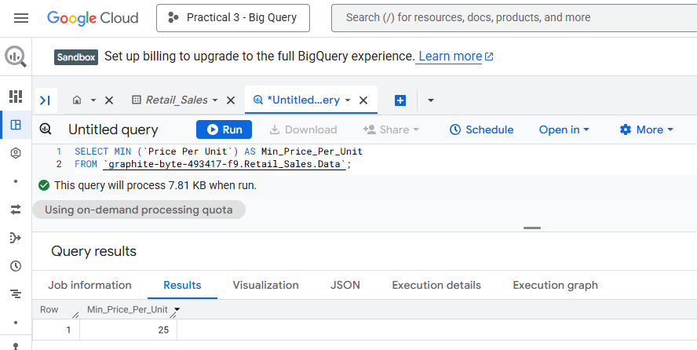
- Find the number of transactions per Product Category.
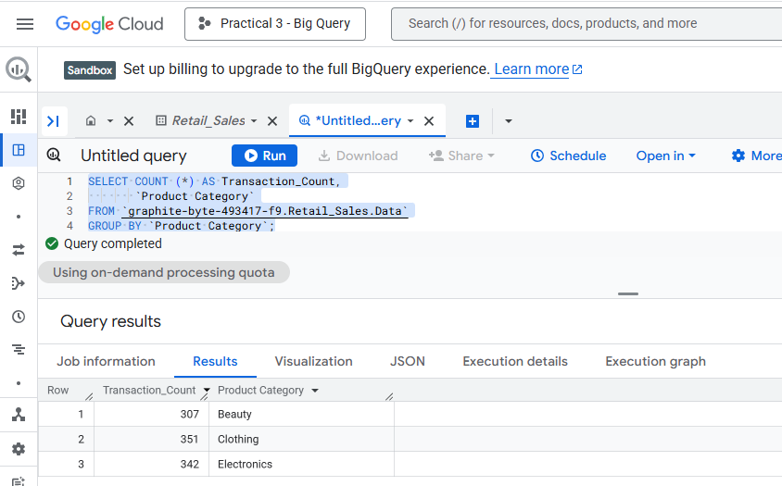
- Find the total revenue (Total Amount) per gender.
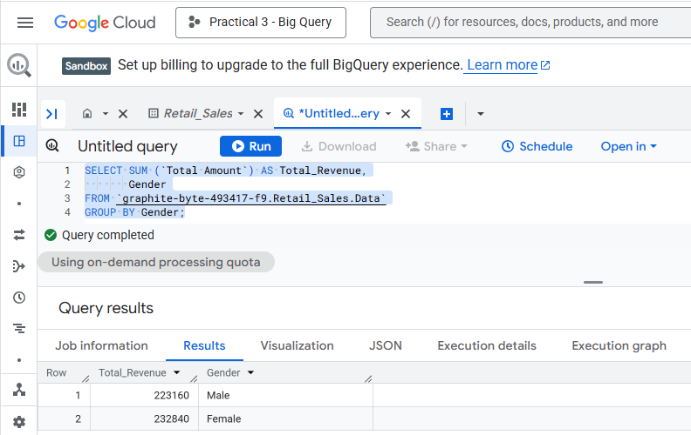
- Find the average Price per Unit per product category.
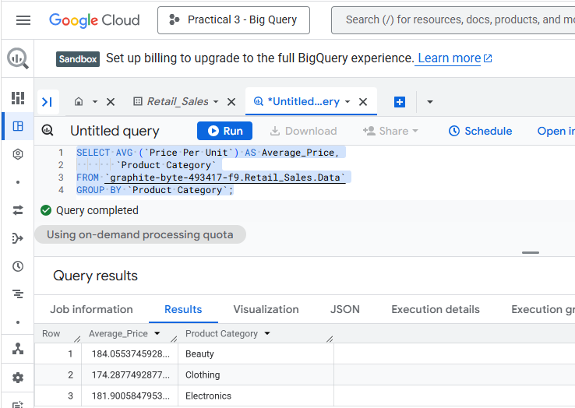
- Find the total revenue per product category where total revenue is greater than 10,000.
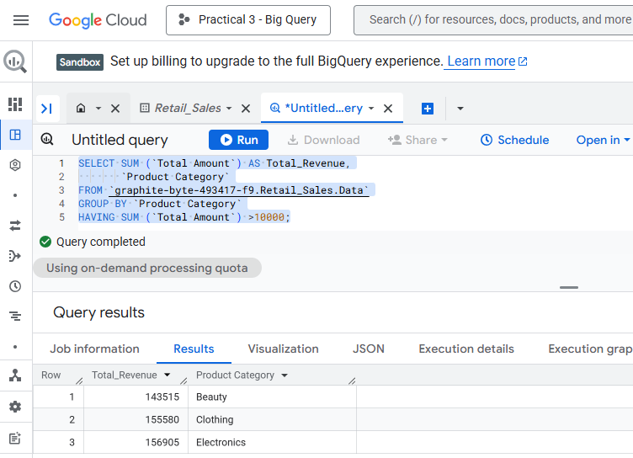
- Find the average quantity per product category where the average is more than 2.
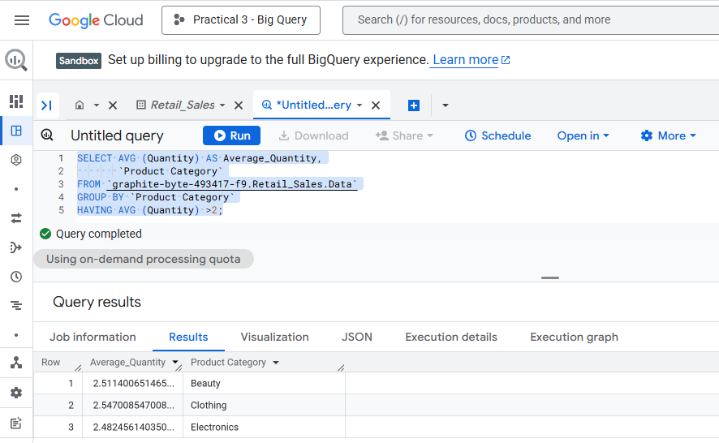
- Display a column called Spending_Level that shows 'High' if Total Amount > 1000, otherwise 'Low'.
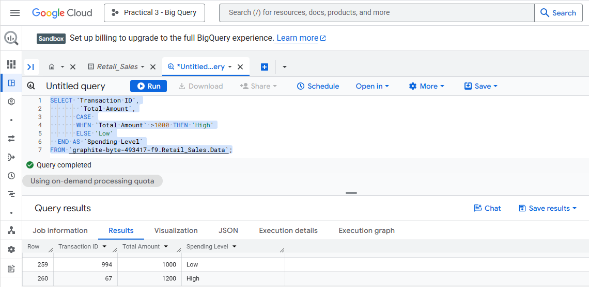
21. Display a new column called Age_Group that labels customers as:
- 'Youth' if Age < 30
- 'Adult' if Age is between 30 and 59
- 'Senior' if Age >= 60 Expected output: Customer ID, Age, Age_Group

